Dear Principal,
Firstly, thank you for continuing to participate in ICAS this year. We really hope you enjoy the celebrations for the great achievements students have shown in winning an ICAS medal.
Whether you hold an in-person or virtual assembly, we really wish we were there to applaud your students for their achievements. To assist with your celebrations, we have put together some fun facts about ICAS that you may want to include in your presentation notes in the medal celebration at your school.
Fun facts
About ICAS | - Over 20 million tests sat over the past 20 years  - Tests developed and delivered in over 30 countries globally, including the United Kingdom, China, India, South Africa and Singapore  - Most popular ICAS year level: Year 5 (AUS) / Year 6 (NZ)  - The team that helps bring ICAS to life hail from all continents on Earth (except for Antarctica)  - The ICAS team has developed over 22,000 test questions since it was first sat by students in 1981.
ICAS medals | - In the last decade ICAS has awarded over 16,000 medals to over 12,000 students  - The most ICAS medals won by one student is 16 medals over a 4-year period.
Subjects
Mathematics | - Most popular ICAS subject  - Shortest question ever asked in ICAS: 6² = ? (Year 7)  - First ICAS subject to be created (alongside Science), when ICAS was created more than 40 years ago.
English | - Second most popular ICAS subject  - English texts have come from picture books, short stories, novels, poems, play scripts, interviews, letters, diary entries, advertisements, web pages, blogs, feature articles, opinion pieces and even comic strips (even William Shakespeare and Charles Dickens have written texts for ICAS English!)
Science | - Longest question ever asked in ICAS was a question about polymers and molecules, with 248 words! (Year 11)  - First ICAS subject to be created (alongside Mathematics), when ICAS was created 40 years ago.
Digital Technologies | - Introductory paper for Year 2 students has been introduced in 2022.
Writing | - Only subject marked by specialised primary and secondary teachers; they focus on both the technical skills and creative skills in every script.
Spelling Bee | - Longest word used in the Spelling Bee competition; ‘enthusiastically’ (16 letters).

Make sure to post and share your school’s medal celebration photos and/or videos on the ICAS Assessments Facebook page (facebook.com/ICASAssessments) by tagging us in your posts and/or by using the hashtag #ICASmedalwinner.
The photos and videos will be used in the ICAS 2022 medal celebration video that can be shared throughout your school community, including with each student’s families and friends.
Check out the ICAS Assessments Facebook page to stay updated on our medal celebration video and to see what other students and schools are sharing. We look forward to your participation, so we can celebrate the achievements of your school’s medal-winning students.
Thank you again for your support throughout 2022. We are very excited for 2023 and can’t wait to see the return of your students for ICAS and Reach next year.
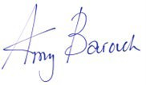
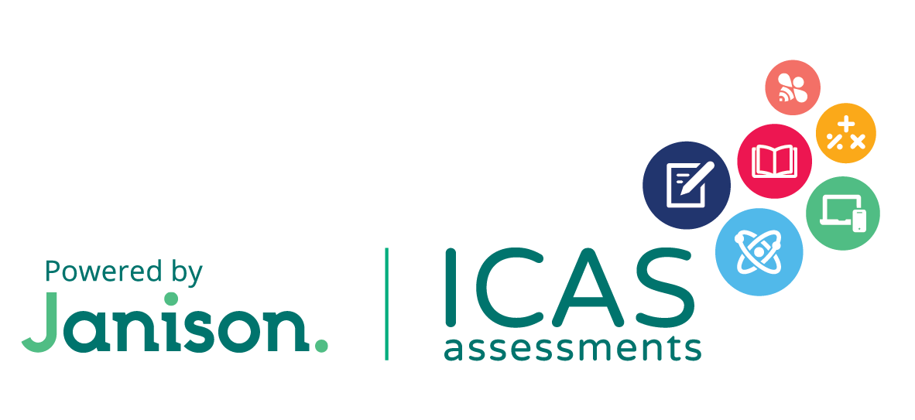
Yours sincerely,
Amy Barouch
Group Executive – Educational Assessments
Janison

